Our product, Dreamlight, is a sleep mask and looks like this from the outside.

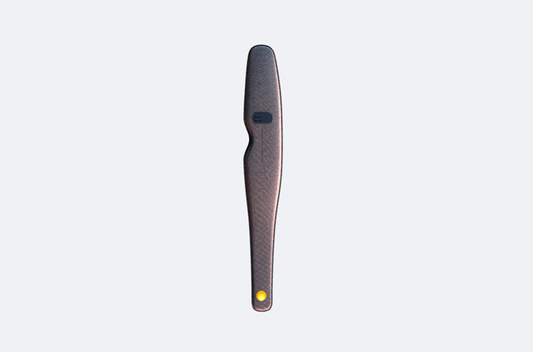

As part of our homepage, we want to implement parallax scrolling with this product. As the user scrolls down, the lights on the Dreamlight turn on one by one and text boxes appear with functionalities about the product. The pictures below roughly highlight where the lights and text boxes are situated on the Dreamlight.

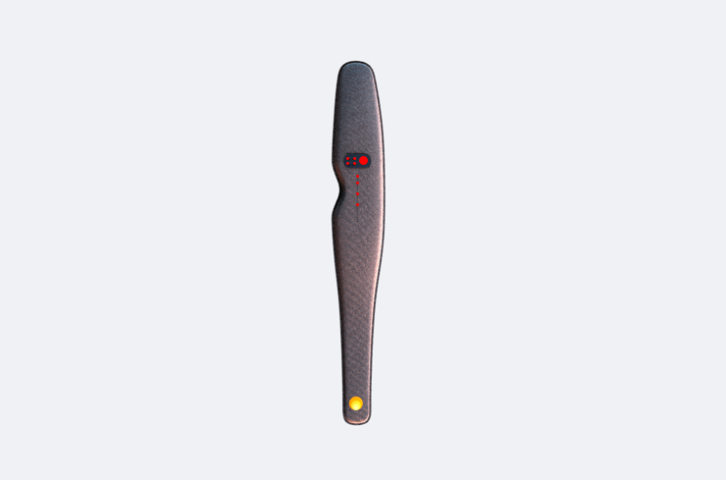

The red dots next to each other are the lights that turn on in the screen. The red dots under it represent some of the several vertical lights that turn on as well. We would provide you with renders and images of these. What we want to know is if you can apply parallax scrolling to these images. This effect would be similar to the one used in this website:

<https://www.apple.com/homepod/>

The website user keeps scrolling down until it sees the top part of the product. The user will then keep scrolling down until the whole length of the website consists of the Dreamlight. Then, a small indication should appear, urging the user to keep scrolling. We would like this to be similar to the one used here:

<https://scytale.pt/>

At this point, the Dreamlight will stay on screen and parallax scrolling will be applied, just like with the Homepod on the apple website. The first ‘scroll’ should make the lights on the screen turn on. Then, each subsequent ‘scroll’ should turn on the 2 vertical lights, starting from the top. Simultaneously, text boxes should fade in, containing information about the product. This would look something like this:

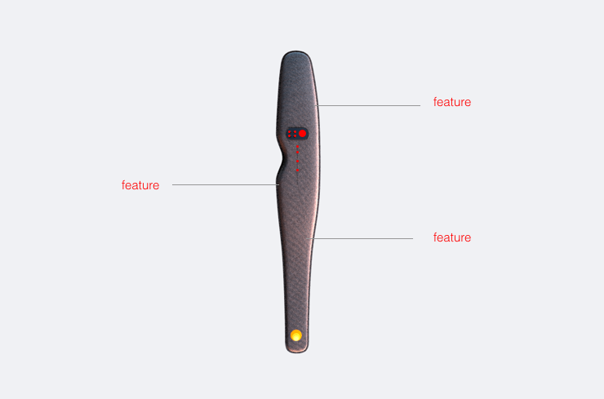

Once we get to the end (so all the vertical lines are now turned on and all text boxes have appeared), the same indication used before should appear again, urging the user to keep scrolling. Now, the next ‘scroll’ should make the text boxes fade out and the Dreamlight to be replaced by a render of its internal components, which looks like this:

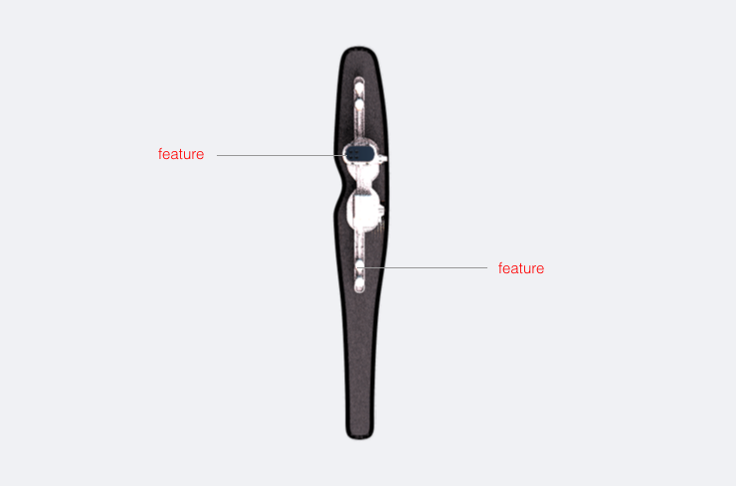

We want to make it look like the user is now looking at an x-ray of the Dreamlight. Subsequent scrolling would bring up text boxes again. After all of the text boxes have appeared, the website would now scroll down to reveal the rest of the website.

Will it be possible for you to implement this effect on our homepage? We will provide design files and all images. If yes, how long would it take to create the homepage, which contains everything mentioned above, as well as the other seven webpages, which do not have any parallax scrolling? Would you also be able to provide me with an estimate for the price you will charge?

Thank you for very much for your time and I hope to hear from you soon.